Analytical SQL Case Study

***Background:***

*Customers has purchasing transaction that we shall be monitoring to get intuition behind each customer behavior to target the customers in the most efficient and proactive way, to increase sales/revenue , improve customer retention and decrease churn.*

*You will be given a dataset, and you will be required to answer using SQL Analytical functions you have learnt in the course.*

Q1- Using OnlineRetail dataset

* write at least **5 analytical SQL** queries that tells a story about the data
* write small **description** about the business meaning behind each query

Q2- After exploring the data now you are required to implement a Monetary model for customers behavior for product purchasing and segment each customer based on the below groups

## Champions - Loyal Customers - Potential Loyalists – Recent Customers – Promising - Customers Needing Attention - At Risk - Cant Lose Them – Hibernating – Lost

The customers will be grouped based on 3 main values

* + **Recency** => how recent the last transaction is (**Hint**: choose a reference date, which is the most recent purchase in the dataset )
  + **Frequency** => how many times the customer has bought from our store
  + **Monetary** => how much each customer has paid for our products

As there are many groups for each of the R, F, and M features, there are also many potential permutations, this number is too much to manage in terms of marketing strategies.

For this, we would decrease the permutations **by getting the average scores of the frequency and monetary** (as both of them are indicative to purchase volume anyway)

**Expected outcome**

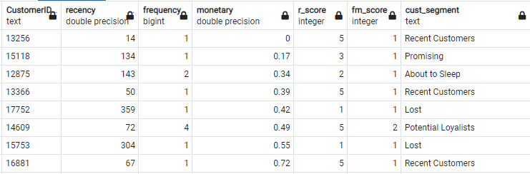

Label each customer based on the below values.

|  |  |  |
| --- | --- | --- |
| **Group name** | **Recency score** | **AVG(Frequency & Monetary ) score** |
| Champions | 5 | 5 |
| 5 | 4 |
| 4 | 5 |
| Potential Loyalists | 5 | 2 |
| 4 | 2 |
| 3 | 3 |
| 4 | 3 |
| Loyal Customers | 5 | 3 |
| 4 | 4 |
| 3 | 5 |
| 3 | 4 |
| Recent Customers | 5 | 1 |
| Promising | 4 | 1 |
| 3 | 1 |
| Customers Needing Attention | 3 | 2 |
| 2 | 3 |
| 2 | 2 |
| At Risk | 2 | 5 |
| 2 | 4 |
| 1 | 3 |
| Cant Lose Them | 1 | 5 |
| 1 | 4 |
| Hibernating | 1 | 2 |
| Lost | 1 | 1 |

Individuals/Teams: **Individual**

Delivery format:

1. File/s (.txt, .sql, .docx) contain your Queries
2. File(.txt) contains your story (it may contain your Queries as well) written in a well-formatted manner